 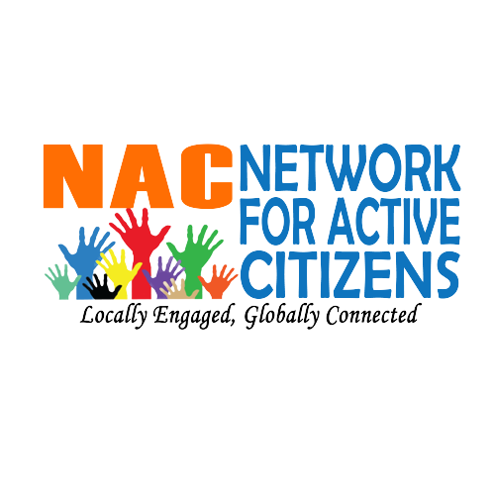

**Youth Defenders Hub:** Strengthening the resilience of youth-led CSOs as HRDs in Arua and Yumbe.

**Expression of interest form**

By filling this for, you express interest to be part of “**Youth Defenders Hub:** Strengthening the resilience of youth-led CSOs as HRDs in Arua and Yumbe.t” project.

Please complete this form and email it to [aldoadomati97@gmail.com](mailto:aldoadomati97@gmail.com) , [ismailbogere2019@gmail.com](mailto:ismailbogere2019@gmail.com) and copy in [mugisha.evelyn@yahoo.com](mailto:mugisha.evelyn@yahoo.com) by 16th January 2025.

Please ensure you answer all the questions.

**About the project**

**Network for Active Citizens (NAC)** with financial support from Defend Defenders is implementing a project titled entitled Youth Defenders Hub project funded by the Defend Defenders. The project aims at strengthening the resilience of youth-led CSOs as grassroots HRDs amidst increasing civic rights abuse. This project focuses on addressing the growing challenges faced by youth-led civil society organizations (CSOs) in Uganda, particularly those serving as grassroots human rights defenders (HRDs). In an environment characterized by increasing civic rights abuses and shrinking civic space, the project aims to fortify the resilience, sustainability, and operational capacity of these organizations.Our initiative is designed to empower youth-led CSOs to navigate systemic obstacles, including restrictive governance frameworks, bureaucratic hurdles, and threats to their independence. Through the Youth Defenders Hub, we seek to provide a safe and collaborative platform that supports grassroots HRDs in their critical work of advocating for accountability, governance reforms, and human rights.

.

|  |  |
| --- | --- |
| Submission Date |  |
| Organization: |  |
| Name of the main contact: |  |
| country |  |
| Role: |  |
| Email: |  |
| Other point of contact (optional): |  |
| Social Media Handles |  |
| I agree to participate in pre and post project activities |  |
| I will have good access to the internet for participating in online pre and post project activities and events. |  |
| I will attend all sessions including online weekly Focused Group Discussions. |  |
| My organization would be comfortable sharing our experiences and lessons learned. |  |

Write a brief about your organization

|  |
| --- |
|  |

Why would you like to be part of this project? (max 200 words)

|  |
| --- |
|  |

What change you would like to see in your community? (Max 200 words)

|  |
| --- |
|  |